**LECTURE 1**

**Myths related to Stock Market**

* Stock Market is very risky – long run = Profit the below graph shows SENSEX rising from 5000 to 35000.
* 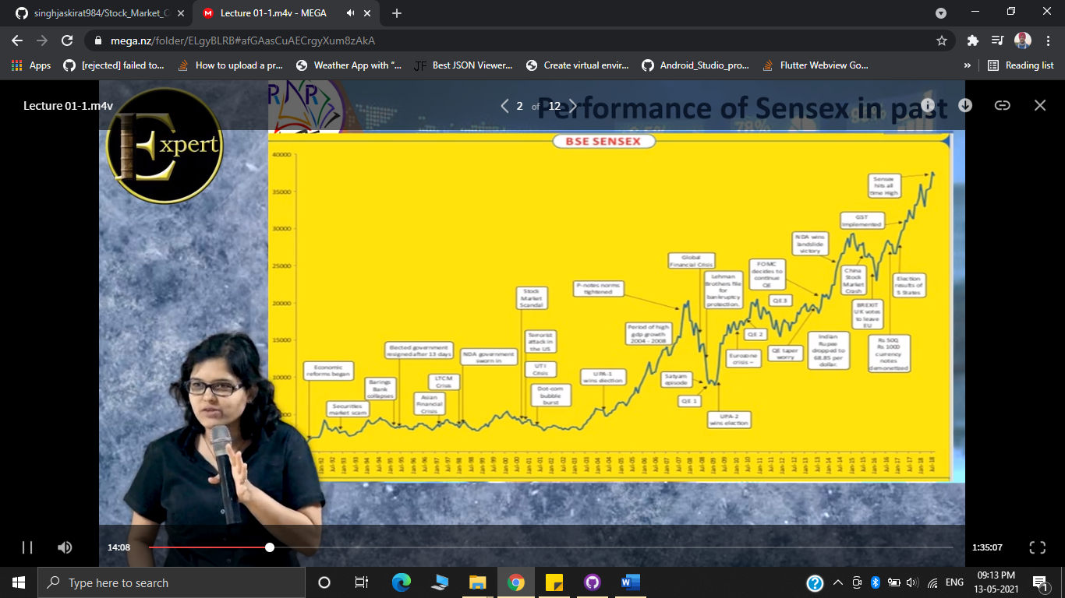
* You need to have very strong knowledge about stock market – No such thing is concrete – people who didn’t have any type of finance background have done wonders in this line.
* **Long term capital gain (LTCG)** – if you buy and hold the shares for more than 1 year, and earn a profit while selling the share, it is known as LTCG**. – advantage of this strategy is that NO INCOME TAX IS APPLIED ON THE PROFIT EARNED THROUGH LTCG.**
* **DIVIDEND –** if we create an FD in bank we get INTEREST, same if we invest in shares we get dividend (its is the return on investment in shares).
* Difference between interest and dividend

|  |  |
| --- | --- |
| **Interest** | **Dividend** |
| On Bank FDs | On Shares |
| Its Mandatory for the bank to pay once declared | Not Mandatory, Can be denied by the company eg: Google, Apple |
| Can only be changed for new FDs | Company can ask investors to re-invest in their more and more products and ventures |
| Taxable | Tax-free |

* **Dividend**
* Dividend is the return on investment in shares
* It is not mandatory for the company to declare a dividend every year
* Dividend and LTCG are Tax-free for individuals.
* Dividend is paid on face value pf the share